## Arcee AI

Demo date: Nov 1, 2024  
Scoping start date: Nov 4, 2024

MSA Signature Date: Nov 4, 2024  
Onboarding Kick Off Date:

[If Exists] Opt Out Date:  
Go Live Date:

GTM POC: Daniel  
Implementation POC: TBD

ERP: QBO

Tax Integration: QBO Hard Coded Taxes

### 

### Key people at Merchant

### CEO: Mark McQuade (mark@arcee.ai)

### ~~Fractional Controller: Ted _____ (ted@neweconomycpa.com)~~

### Chief of Staff / Billing: Molly Niland (molly@arcee.ai)

### Revenue Ops: Amber _____ (amber@arcee.ai)

* Business Operations: Mohit Khullar (mohit@arcee.ai)

### Company summary

Platform allowing companies to use Small Language Models (SLMs) to fuel innovation while still retaining full control over their data and models.

Arcee makes that world a reality with our end-to-end system for merging, training, and deploying Small Language Models (SLMs) that you own and that are adapted to your domain and data. Our solution is user-friendly and enables seamless deployment to any cloud or platform for inference.

Goals (North star)

What is the merchant's goal? To automate all billing and revenue workflows. Their biggest pain point is ballooning AR, due to manual invoicing and dunning processes. Really like the improved time to invoice w/ Tabs as well as the collections view. ARR and Rev Rec reporting will be important as well as cash forecasting, as they’re starting to prep for their Series B round in 1Q25.  
  
No opt out clause.  
  
AE Notes

Any important relationship information  
  
1) What is Merchant Temperament?

CEO is the decision maker. He seemed frustrated with the previous invoicing process, but was very friendly and approachable. He moves fast and has a technical background (former CTO).

2) Is there key POC the buyer/decision maker?

Mark is the decision maker who gave the final thumbs up. He had us do a second demo with his team to get their sign-off ahead of time. Ted is the fractional controller who will be a power user, along with Molly who has been managing billing thus far.

3) What are the Tabs features the key POC cares about?

Contract ingest, collections kanban, cash application, dunning emails, revenue reporting

### Billing model

* Info on how merchant bills
  + Had milestone payments in previous contracts but moving towards pure saas solution
* How contract is broken up
  + Varying payment terms. Some annual upfront but depends on the client
* One off things to know about merchant

### Billing model

* Are there unique things about the customer creation process for this merchant?
  + Nothing unique

### 

### 

### 

### 

### 

### Contract Processing Steps

1. Steps to process

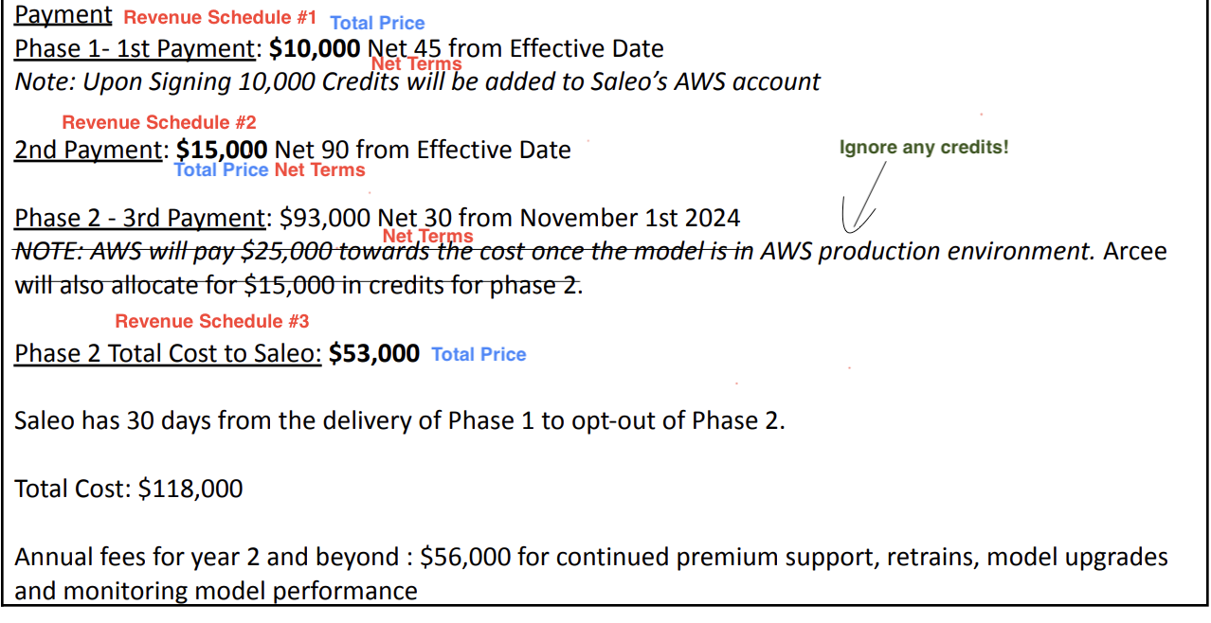

* 1. For contracts that look like the screenshot above, use screenshot and [LOOM video recording for reference](https://www.loom.com/share/d449a5be7d654f20be63ebce0699c9e8?sid=82660fd2-0c81-451a-b9c7-42a2ddb359ff), [example garage contract](https://garage.tabsplatform.com/prod/contracts/70ba68eb-56fe-4153-b320-4ca78f045df3/terms/revenue)
     1. Create a revenue schedule for each payment listed (this example lists 3 payments)
        1. Revenue Schedule #1/2/3
           1. Service Start Date: Mentioned in contract under “agreement date”
           2. Months of Service: length of contract
           3. Item Name: Name of Payment, example “ Phase 1- 1st Payment”
           4. Total price: Listed in contract, each phase will list a total price
           5. Start Date: Same as service start date
           6. Periods: 1
           7. Frequency: None
           8. Net Terms: Listed next to total price in contract
           9. Integration Item-SAAS Revenue

If a contract looks like the screenshot below, please follow the steps listed: [Watch walkthrough video here](https://www.loom.com/share/ad5b15df63794adfb96909b43e9ab4cb?sid=def61af3-65b2-4542-9748-1d403c0394a0)

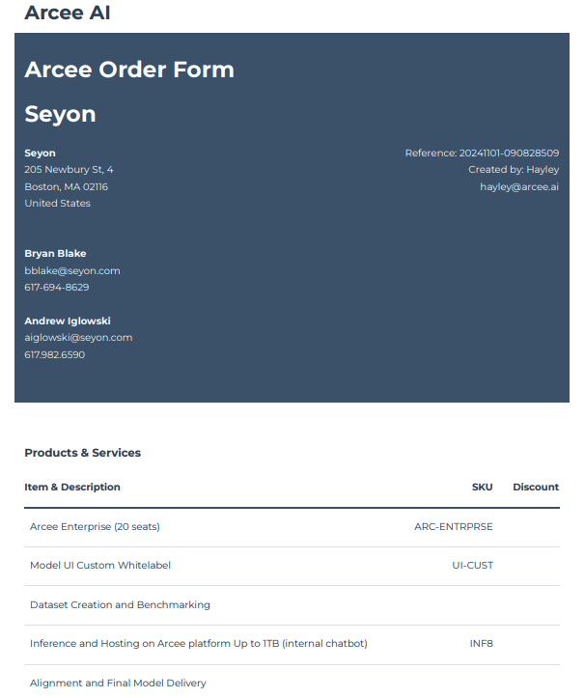

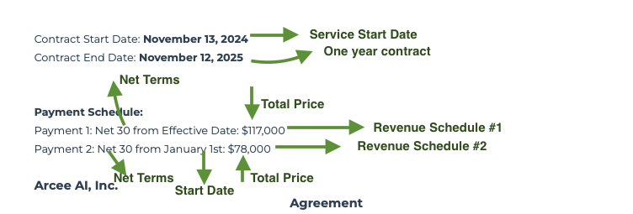

* 1. Create a separate revenue schedule for each **PAYMENT schedule** listed in the contract
     1. Service Start Date: See contract for “Contract Start Date”
     2. Months of Service: length of contract
     3. Item Name: Name of Payment, example “ 1st Payment”
     4. Total price: Listed in contract, each payment line item will list a total price
     5. Start Date: Refer to contract for each payment schedule
     6. Periods: 1
     7. Integration item= SAAS Revenue
     8. Frequency: None
     9. Net Terms: Listed next to total price in contract

1. Anything to ignore in contracts?
   1. Ignore any credits and pricing and invoicing
2. Specifics processing things merchant has requested that may differ by contract (e.g. always back-date invoice date to final day of the month)
3. Default Service Term
   1. If None Listed, Ops Default is 1 Year
4. Default Net Payment Terms
   1. Default 30
5. Default Billing Frequency
   1. Refer to contract
6. How do we handle taxes as a line item?
   1. No taxes

### Events Processing (if necessary)

* Any important information on events billing

Integration Items Processing (if necessary)

* What are the instructions for assigning integration items?
* Example: All Statsig integrations items should be labeled as “Sales”
* Example: All “Pinata” integration items should be labeled as “Software Subscription Bundle” unless otherwise noted by Merchant

Post Processing Communications (if necessary)

* Does Ops Team need to notify anyone on the team re: completion of processing batches in Implementation or Active phase?
* Who needs to be notified and when?
  + Example:
    - Who: Customer Success [Azmat Aziz] needs to be notified
    - Where: Messari internal merchant channel
    - When: contracts are processed [Merchant Phase: Active]

### Customer Information

* Any important information on specifics customers of this merchant
  + Nothing specific

### Feature Requests

* FR 1
  + Hubspot integration
  + Would like to push payment info and past due balances back to Tabs
  + Framed it to them that it is a work in progress

### Rewatch Calls

* [Intro Call](https://tabs.rewatch.com/autocomplete/redirect_search?terms%5B%5D=Arcee&url=%252Fvideo%252Flwmx6n9namsztkdg-tabs-intro-arcee-ai-november-1-2024) - November 1, 2024